Name:
- My theme is

- The classes we offer are

- Integrated Curriculum unit ideas (that match my theme)

- Field trips we can take to match our theme are

- See Curriculum matrix

- My list of teachers and the classes they teach (can include lesson ideas)

- I will sit down with my team of teachers and start developing lesson plans and planning field trips on (dates/times)

- We will showcase our work by

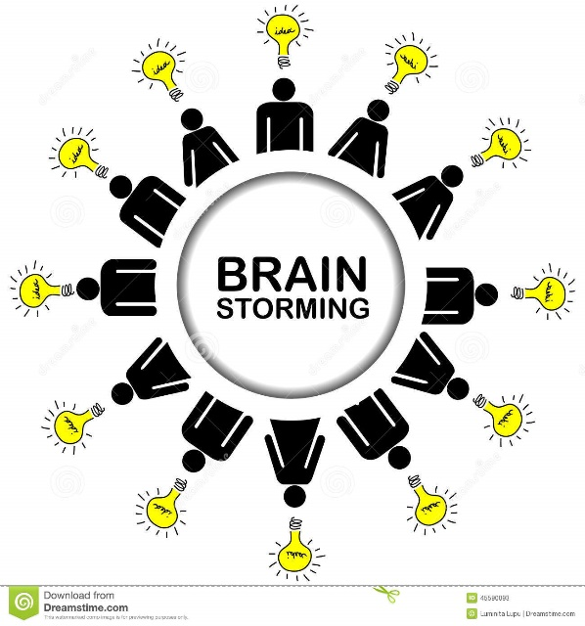
Use this space to brainstorm ideas with other session participants!

